

Professional Practice

Jomo Batola

Assignment 2 – Report writing

bEST FUTURE PROOF PROGRAMMING LANGUAGE FOR A bEGINNER WEB DEVELOPER

LIS | Web Design and Development | May 8, 2015

Table of Contents

Introduction 2

Method 3

Findings 5

Discussion 9

Reflection 11

Conclusions 11

References 11

Bibliography 11

Appendix 11

# Introduction

Since the 1960s, many programming languages have been created and used by programmers. For some, they enjoyed brief popularity before quickly declining, whilst others never became popular **(Anon, 2013).** Today, there are many languages that Web designer and developer can choose from **(Diana 2012),** but the question that looms for those starting in the industry is what the right language is to invest time in and learn. This is the question this report aims to answer; analyzing all programming languages today to see which one would be the smartest investment for a beginner web developer. For this report it will be assumed that the hypothetical developer already knows HTML and CSS. But has no experience with programming/scripting languages.

**Aim:** *To establish which programming language provide the most secure future for a beginner web developer.*

**Objectives:**

* To investigate each popular programming language suitable for a web developer
* Determine the most important factors a web developer must think about when determining what language he should invest his time in
* Derive the language that best fits all the criteria that makes it the best suited language for beginner web developer

# Method

In order to achieve the above objectives. Time firstly needs to be planned. The planning would involve creating a Gantt chart (appendix A). This would help organize time. It’s also more efficient, in terms of time management. Research will be carried out after this, all of which will be secondary sources, as no primary research would be undertaken in this project.

**Criteria**

The criteria below picks apart the features of each language. It also takes into account external factors, such as demand, and usefulness. The criteria was made to be both diverse and objective. Each criteria below has a justification for why it has been chosen as a suitable factor to making a good programming language to learn.

**External support**: A great community is important for any language as it means that there is a lot of support for new learners. This also means more frameworks, libraries, etc. Support in this criteria also means, how is the language supported on browsers, computer systems? Is it preinstalled on many devices? Or does it need to be installed no matter the system. This is vital to see how accessible the language is?

**Ease of learning**: This would be part of the criteria as it’s critical that the language is easy to learn. A language that is too difficult risk having new-comers get frustrated and give up trying to learn.

**Design**: Efficiency is defined as a code that is well designed, thus is practical, logical and doesn’t contain too many inconsistencies, quirks and other work around that make it difficult to use. This is important as having a code that is poorly designed can lead to bad habits, less efficient code etc.

**Popularity and demand**: Popularity is vital, and arguably the most important criteria. A coding language that is very popular is unlikely to fall out of use. Thus making it secure. A popular language also likely has a large community, an extensive amount of documentation and a plethora of books and sites dedicated to teaching it. Demand is also vital. A language may not be popular for the time being, but if it is seeing strong demand, then that can signal that the language will soon start rising in popularity. On the flipside, a language could be popular, but may start to see strong decline, meaning the language may be dying. Demand and popularity of languages can be measured by looking at a number of indexes that look at long term trends of the use and mention of the language.

**Usefulness:** It’s function. How useful will the language be for the web developer?

# Findings

The languages being looked at include JavaScript, PHP, Java, Python, and Ruby. As these are languages most commonly used for web development **(Muzic 2014)** the general criteria will be: external support, the ease of learning, efficiency, popularity and demand, usefulness and salary potential.

A monthly report done by the organization Tiobe index measures the popularity of programming language. The index is based on search engine results, courses, third part vendors **(Tiobe n.d).** Looking at the table shown in figure 1. The source Toibe **(n.d)** has found that JavaScript has secured its highest position ever. Whilst PHP has seen negative growth, resulting in it being overtaken by JavaScript. Ruby in February declined significantly, dropping from 14th place in January to 18th place. Others have seen no change.

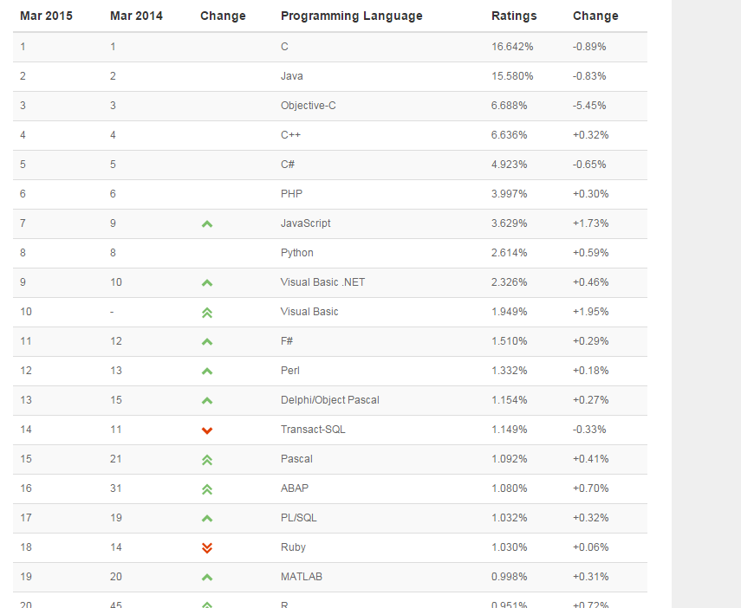

Figure 1

In figure 2, long term trend of the languages popularity are seen. JavaScript has remained stables, whilst PHP and Python has seen massive growth since 2000. Java has been top of the list, with exception being in the year 2000, where it was ranked third.

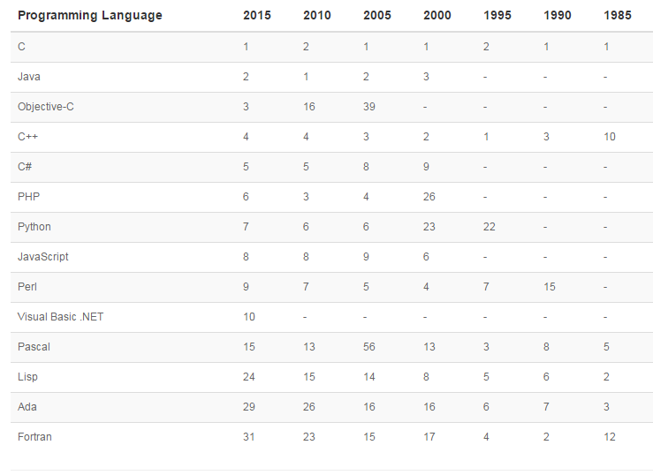

Figure 1.1

According to another index - gooroo, which analysis over four million job adverts. It shows that JavaScript is mentioned in 13% of all job listings, 14.5% for Java. Ruby has an average frequency of over 2%. **(Johnson 2015)**

For the job site, indeed, JavaScript was a keyword in a total of 1% of all job listings. Its related libraries had also seen growth. For node.js the growth has been 80,000% over the last three years. And angular.js 9,000% in the last year. JQuery is now ranked at 8# on the fastest growing keywords on the site. **(Birnir 2014)**

Another set data examined by jobs tractor which looks at jobs advertised on twitter, show PHP and Java are high in demand **(Craig Buckler 2014)**

As a server side language, PHP is at the top, accounting for over 82% of websites. Up from 75% last year. Second was asp.net with 17% share, and java which accounted for 2.8% for all websites. Ruby, python and JavaScript had 0.6, 0.2, and 0.1 respectively. **(Anon, n.d)**

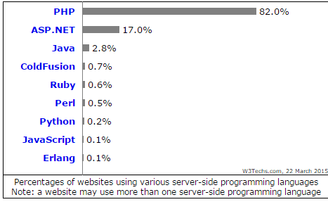

**Figure 2**

For client side, JavaScript was the most widespread used language, accounting for 88.5%, whilst java accounted for 0.1%. **(Anon n.d)**

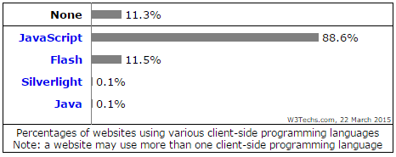

Figure 2.2

# Discussion

To narrow down the languages, the languages suitable for web development were chosen. This cut down on a huge number of languages which were better suited for app and software development. Other big languages like C# and Java were not focused on due to the nature of these languages not being best suited for web developer just beginning. () Not only are the learning curve high for these languages, they may also be not most suitable for building a website front end.()

Python

Regarding ease of learning, python seems to come on top. From several sources and some prominent engineers such as H.P, the language has been touted as the best programming language for a beginner, due to its easy to understand syntax **(Eadicicco 2014).** Not only is its syntax easy, its rigidness fosters good practices when coding; forcing coders to be more efficient **(Johnson 2014)**. However, the syntax itself is also a disadvantage. It’s very different to the familiar C syntax that many languages such as JavaScript and PHP have drawn influence from. This alien syntax scares away many developers who are used to the C influenced syntax, which may become a hindrance for python. **(Castro-Castilla 2014)**

JavaScript

JavaScript was created in the late 90s under the name of mocha, but was then changed to live Script, then in the same year, JavaScript **(W3C n.d).** Java script is sometimes called the programming language of the web, as the usage is widespread **(W3tech, n.d).** The language is also ideal for beginners as it’s not only supported by with vast amount of resources, it also built into most modern browsers, so all that is needed is a code editor. Learner can start right away, the same cannot be said for ruby and python **(Birnir 2014)**

In recent years the language has shown itself to be more versatile and robust than was previously thought. It has seen huge amount of growth, particularly with the creation of libraries such as Ajax and j-query **(Loukides 2011).** Lots of work has been put into making JavaScript a more serious language, and this indicates a supportive and dedicated community. JavaScript is beginning to move up on the server side with Ajax and node.js **(Birnir 2014)** this makes JavaScript the only web language that both backend and front end.

PHP

PHP dominates the server side world, with it being the choice for over 85% of websites **(W3tech, n.d)**, including Facebook, Amazon and Digg **(Troxo, 2008).** This gives it a good ranking on popularity and widespread use. The sheer dominance of php makes for a very good community, and tons of resources online. In addition, php is initially easy to learn. Coming with a large array of built in functions. It easily runs on most platform such as windows and UNIX **(Reid, 2014)**

Due to a low entry barrier, PHP suffers from being poorly designed. From lack of consistency, full of exceptions and generally unreliable **(Eevee, 2012),** this makes it terrible inefficient. This leads many to believe that PHP promotes poor coding practices, which is a contrast to the clean design of python. These issues are the biggest disadvantage of PHP, which have been noted by experts **(Odell 2010)**.

PHP doesn’t enjoy the same salary potential as JAVA, Ruby and Python, but being a popular language used by many websites, its demand remains strong, particularly with the growing number of sites that are built off word press and drupal, which is run on PHP**(Paul J, 2013).**

Ruby

Ruby is popular for startup languages, like python it’s very expressive, has huge libraries lie ruby on rails and has a clean syntax that is easy to work with, this is ideal for beginner **(Bien 2013).**

However, ruby comes with a couple of disadvantage. Its major downfall for now, is that it’s not as popular as the other languages in this report; ranking at 18th on the tiobe index. This also means that the community surrounding it is still small, not near the level of the large community for PHP and Java. The language also doesn’t have the advantage of being easy to just start, like JavaScript. Although, some computer platforms have it pre-installed and it’s a step ahead of Python **(Krill, 2015)** in that there are ways to play with it on the browser **(ruby n.d)**

Java

Java has long remained at the top of Tiobe index, beating out JavaScript, Python and PHP. (Tiobe n.d). The language also performs well in the Gooroo index **John (n.d).** This makes JavaScript a very popular language. Java is also has a relatively high number of sites that use it for server end **(W3techs, n.d),** these sites include Amazon, Sam’s club and the Apple store **(shiotsu, 2014).**

One issue with Java is that can be a difficult to learn for a programmer, whilst the language can be provide benefits in making a web developer think like a true programmer using logic and analytically, the language itself is difficult to grasp, which can make it difficult to program effectively, this all noted by **Henry(2014).**

# Reflection

Important skills gained during this assignment include the following: organization, research, and problem solving.

For organization, this included organizing time, and allocating time to complete the report.

The most important skill for this assignment is problem solving. The main purpose of the assignment is to define a problem and find a solution. This is what was done, the problem was defined: Beginner web developer looking for the most safeguard/best programming language, and then solved using a wide range of information. Thus, this task was vital for understand the steps it takes to solve any given problem.

# Conclusions

The choice between choosing a language that would be most beneficial for themselves in future is a tough one and has been shown in this report, one that depends on a wide range of factors. As stated by Craig Buckley **(2014)** languages rise and fall in both popularity and demand. But, what’s important is the timescale. JavaScript is set for a long future with an exciting future **(John, 2014).** It has as a few commonalities with others languages such as C to make the transitions easier for a developer **(MacDonald 2013).** The language is easy to learn and developers can start right away **(Birnir 2014).** Whilst JavaScript comes with a number of flaws, the benefits seem to outweigh them. Overall, is has been concluded that JavaScript in general is the best option for a developer choosing a first language.

# List of figures

**Figure 1:**

Tiobe, n.d [List of popular languages in the month of April] [digital online] available at: <http://www.tiobe.com/index.php/content/paperinfo/tpci/index.html>

**Figure 1.1:**

Tiobe, n.d [List of year by year average of most popular language] [digital online] available at: <http://www.tiobe.com/index.php/content/paperinfo/tpci/index.html>

**Figure 2:**

W3tech n.d [Most popular sever side language used by websites] [digital online] available at: <http://w3techs.com/technologies/overview/programming_language/all>

**Figure 2.1:**

W3tech n.d [Most popular client side language used by websites] [digital online] available at: <http://w3techs.com/technologies/overview/client_side_language/all>

# References

Anonymous (no date) *Usage Statistics of Client-side Programming Languages for Websites, May 2015*. Available at: http://w3techs.com/technologies/overview/client_side_language/all (Accessed: 8 May 2015)

Birnir, A. (2014) *The first programming language you should learn is…*. Available at: http://skillcrush.com/2014/04/10/learn-javascript/ (Accessed: 8 May 2015)

Buckler, C. (2014) *What is the Best Programming Language to Learn in 2014?*. Available at: http://www.sitepoint.com/best-programming-language-learn-2014/ (Accessed: 29 April 2015)

Castro-Castilla, Á. (2014) *The Best Programming Language (or How to Stop Worrying and Love the Code) - The Blog of Fourthbit*. Available at: http://blog.fourthbit.com/2014/03/01/the-best-programming-language-or-how-to-stop-worrying-and-love-the-code (Accessed: 8 May 2015)

Diana, R. (2012) ‘The Big List of 256 Programming Languages’,

Eadicicco, L. (2014) *The Best Programming Languages Every Beginner Should Learn*. Available at: http://uk.businessinsider.com/best-programming-languages-2014-12 (Accessed: 8 May 2015)

Eevee and Posted by Eevee in reference (2012) *PHP: a fractal of bad design / fuzzy notepad*. Available at: http://eev.ee/blog/2012/04/09/php-a-fractal-of-bad-design/ (Accessed: 8 May 2015)

*Henry, A. (no date) Five Best Programming Languages for First-Time Learners. Available at: http://lifehacker.com/five-best-programming-languages-for-first-time-learners-1494256243 (Accessed: 8 May 2015)*

*IT Jobs Watch, Tracking the IT Job Market* (no date) Available at: http://www.itjobswatch.co.uk/default.aspx?page=1 (Accessed: 29 April 2015)

John, S. . (2014) *JavaScript – Evolution, Dominance and the Future - ALIGNMINDS TECHNOLOGIES*. Available at: http://www.alignminds.com/blog/javascript-evolution-dominance-future/ (Accessed: 8 May 2015)

Johnson, P. (2014) *Python programming language squeezes out JavaScript, C as best for beginners*. Available at: http://www.itworld.com/article/2693392/python-squeezes-out-javascript-c-as-best-starter-programming-language.html (Accessed: 8 May 2015)

Johnson, P., #Tech By Phil Johnson Follow and follow the latest IT news at ITworld. Follow Phil (2014) *The most in-demand (and valuable) programming languages*. Available at: http://www.itworld.com/article/2693638/the-most-in-demand-and-valuable-programming-languages.html (Accessed: 29 April 2015)

Joseph, C. (no date) *Programming languages - salaries and demand (October 2014)*. Available at: https://gooroo.io/GoorooTHINK/Article/16225/Programming-languages--salaries-and-demand-October-2014/17081#.VUAHfiFVhBc (Accessed: 28 April 2015)

Krill, P., InfoWorld, P. K. F., PT, 2015 1:35 PM and focuses, whose coverage (2015) *A developer’s guide to the pros and cons of Python*. Available at: http://www.javaworld.com/article/2889715/scripting-jvm-languages/a-developers-guide-to-the-pros-and-cons-of-python.html (Accessed: 8 May 2015)

Loukides, M. (2011) *Why a JavaScript hater thinks everyone needs to learn JavaScript in the next year - O’Reilly Radar*. Available at: http://radar.oreilly.com/2011/06/time-to-learn-javascript.html (Accessed: 8 May 2015)

MacDonald, B. (2013) *Which Language Should You Learn First? - O’Reilly Radar*. Available at: http://radar.oreilly.com/2013/11/which-language-should-you-learn-first.html (Accessed: 8 May 2015)

O’Dell, J. (2010) *8 Experts Break Down the Pros and Cons of Coding With PHP*. Available at: http://mashable.com/2010/11/19/pros-cons-php/ (Accessed: 8 May 2015)

*Programming Language Popularity* (2013) Available at: http://langpop.com/ (Accessed: 28 April 2015)

Reid, T. (2014) *Learn Which Programming Language to Choose With This Infographic*. Available at: http://lifehacker.com/learn-which-programming-language-to-choose-with-this-in-1669612111 (Accessed: 8 May 2015)

Ruby (no date) *Documentation*. Available at: https://www.ruby-lang.org/en/documentation/ (Accessed: 8 May 2015)

*Shiotsu, Y. (2014) Web Development 101: Top Web Development Languages in 2014. Available at: https://www.upwork.com/blog/2014/03/web-development-101-top-web-development-languages-2014/ (Accessed: 8 May 2015)*

TIOBE (no date) *TIOBE Software: The Coding Standards Company*. Available at: http://www.tiobe.com/index.php/content/paperinfo/tpci/index.html (Accessed: 28 April 2015)

W3C (no date) *A Short History of JavaScript*. Available at: https://www.w3.org/community/webed/wiki/A_Short_History_of_JavaScript (Accessed: 8 May 2015)

W3techs (no date) *Usage Statistics and Market Share of Server-side Programming Languages for Websites, May 2015*. Available at: http://w3techs.com/technologies/overview/programming_language/all (Accessed: 8 May 2015)

WiseGeek (no date) *What Are the Pros and Cons of PHP? (with picture)*. Available at: http://www.wisegeek.com/what-are-the-pros-and-cons-of-php.htm (Accessed: 8 May 2015)

Wright, N. (2013) Available at: http://readwrite.com/2013/08/09/why-javascript-will-become-the-dominant-programming-language-of-the-enterprise (Accessed: 8 May 2015)

*8 Experts Break Down the Pros and Cons of Coding With PHP* (2010) Available at: http://mashable.com/2010/11/19/pros-cons-php/ (Accessed: 8 May 2015)

# Bibliography

Alexander, G. (no date) *Top 10 Programming Languages That Keep You Employed*. Available at: http://it.toolbox.com/blogs/programming-life/top-10-programming-languages-that-keep-you-employed-39545 (Accessed: 8 May 2015)

Anon (no date) *Javascript Advantages And Disadvantages | JScripters.com: developing a site with Javascript*. Available at: http://www.jscripters.com/javascript-advantages-and-disadvantages/ (Accessed: 8 May 2015)

Anonymous (2012) *PHP: The Ins and Outs, The Pros and Cons*. Available at: http://www.talener.com/php-the-ins-and-outs-the-pros-and-cons/ (Accessed: 8 May 2015)

Anonymous (no date) *Understanding the Pros and Cons of .Net and Java*. Available at: http://www.streetdirectory.com/travel_guide/119922/technology/understanding_the_pros_and_cons_of_net_and_java.html (Accessed: 8 May 2015)

Asay, M. (2014) Available at: http://readwrite.com/2014/09/17/cobol-programming-language-hot-or-not (Accessed: 8 May 2015)

Asay, M. (2015) Available at: http://readwrite.com/2015/03/09/angularjs-backbonejs-javascript-frameworks (Accessed: 8 May 2015)

Brooke, N. (2011) *Pros and Cons of Using Java in your Website*. Available at: http://www.ignitionmedia.com.au/programming/pros-and-cons-of-using-java-in-your-website/ (Accessed: 8 May 2015)

Column Five (no date) *Infographic: Code Wars: PHP vs Ruby vs Python - Who Reigns Supreme - Column Five*. Available at: http://www.columnfivemedia.com/work-items/infographic-code-wars-php-vs-ruby-vs-python-who-reigns-supreme (Accessed: 8 May 2015)

Condo, C. (2014) *Top 5 Web Programming Languages to Begin Learning in 2014*. Available at: http://codecondo.com/top-5-web-programming-languages-begin-learning-2014/ (Accessed: 8 May 2015)

Dave (2013) *Ruby is beautiful (but I’m moving to Python)*. Available at: http://wit.io/posts/ruby-is-beautiful-but-im-moving-to-python (Accessed: 8 May 2015)

DurAi, C. (2012) *Using AJAX – Pros and Cons | PHP SNIPPETS on WordPress.com*. Available at: https://chelladuraii.wordpress.com/2012/09/15/using-ajax-pros-and-cons/ (Accessed: 8 May 2015)

Ferg, S. (2009) *Python & Java: A Side-by-Side Comparison*. Available at: https://pythonconquerstheuniverse.wordpress.com/2009/10/03/python-java-a-side-by-side-comparison/ (Accessed: 8 May 2015)

Ferguson, A. (no date) *A History of Computer Programming Languages*. Available at: http://cs.brown.edu/~adf/programming_languages.html (Accessed: 8 May 2015)

Finley, K. (2014) ‘Julia offers a glimpse into what programming languages might look like in the not-too-distant future (Wired UK)’,

Hurrel, G. (2007) *Ruby: pros and cons · wincent.com*. Available at: https://wincent.com/wiki/Ruby:_pros_and_cons (Accessed: 8 May 2015)

Indeed (no date) *PHP Developer Salary*. Available at: http://www.indeed.com/salary/PHP-Developer.html (Accessed: 8 May 2015)

Jackson, J. (2014) *Python bumps off Java as top learning language*. Available at: http://www.javaworld.com/article/2452940/learn-java/python-bumps-off-java-as-top-learning-language.html (Accessed: 8 May 2015)

Javarevisited (2013) *10 Reasons to Learn Java Programming Language and Why Java is Best*. Available at: http://javarevisited.blogspot.co.uk/2013/04/10-reasons-to-learn-java-programming.html (Accessed: 8 May 2015)

Long, J. (2012) *I Don’t Speak Your Language: Frontend vs. Backend - Treehouse Blog*. Available at: http://blog.teamtreehouse.com/i-dont-speak-your-language-frontend-vs-backend (Accessed: 8 May 2015)

McAllister, N. (2012) *10 programming languages that could shake up IT*. Available at: http://www.pcadvisor.co.uk/news/software/3327573/10-programming-languages-that-could-shake-up-it/ (Accessed: 8 May 2015)

Mediacollege (no date) *The Pros and Cons of JavaScript*. Available at: http://www.mediacollege.com/internet/javascript/pros-cons.html (Accessed: 8 May 2015)

*Overall Skill Trends* (no date) Available at: https://www.elance.com/trends/skills-in-demand (Accessed: 8 May 2015)

Senk, S. (2013) *Ruby vs Python*. Available at: http://www.senktec.com/2013/06/ruby-vs-python/ (Accessed: 8 May 2015)

Shan, P. (2014) *Reasons to use JavaScript, with Pros and Cons!*. Available at: http://voidcanvas.com/reasons-to-use-javascript-with-pros-and-cons/ (Accessed: 8 May 2015)

Titlow, J. P. (2013) Available at: http://readwrite.com/2013/01/30/top-7-in-demand-tech-skills-for-2013 (Accessed: 8 May 2015)

Troxo (2008) *Blog Archive » Most popular websites running on PHP*. Available at: http://wheel.troxo.com/2008/01/08/most-popular-websites-running-on-php/ (Accessed: 8 May 2015)

Wayner, P., InfoWorld, P. W. F. and 2014 (2014) *12 predictions for the future of programming*. Available at: http://www.infoworld.com/article/2610221/application-development/12-predictions-for-the-future-of-programming.html (Accessed: 8 May 2015)

Web designer (2011) *Pros And Cons Of Using Frameworks*. Available at: http://www.1stwebdesigner.com/pros-cons-frameworks/ (Accessed: 8 May 2015)

*What Are the Pros and Cons of PHP? (with picture)* (no date) Available at: http://www.wisegeek.com/what-are-the-pros-and-cons-of-php.htm (Accessed: 8 May 2015)

Yegulalp, S., InfoWorld, S. Y. F., PT, 2015 12:52 PM, focused and reviews, periodic (2015) *5 projects that push Python performance*. Available at: http://www.javaworld.com/article/2881907/scripting-jvm-languages/5-projects-that-push-python-performance.html (Accessed: 8 May 2015)

# Appendix

**Appendix A: Gantt chart**

# 